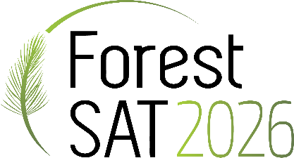
Pre-Conference Workshop
Submission Template

WORKSHOP PROPOSAL SUBMISSION DUE DATE: JUNE 30, 2025

Date of Workshops: Monday, May 4, 2026

Choose your workshop length of time preference: | Choose your optimal attendance size:
- 3-hours of instructional time (3.5-hour session with one 30-minute break) | - 10-20 attendees
- 6-hours of instructional time (8-hour session with two 30-minute breaks and a one-hour lunch) | - 20-30 attendees
___________________________________________________________________________________________________________

Workshop Topic: (Indicate what suggested topic you are covering: Remote Sensing Data Processing, Deep Learning Applications, Forest Carbon and Biodiversity Analysis, or Emerging Trends in Forestry Research)

Proposed Workshop Title: (Concise, descriptive and use proper title case)

Workshop Description/Abstract: (In detail, describe the goals, content and target audience)

Learning Objectives: (Key skills and knowledge participants will gain by attending)

Draft Workshop Agenda/Format: (Describe workshop activities (lecture, discussion, hands-on) and approximate duration of each)

Participant Pre-requisites and Requirements for Attendance: (Specific field of study or scope (knowledge level: beginner, intermediate or advanced), laptop, software, equipment, etc.)

Workshop Organizers and Instructor Qualifications: (In the grid below, provide contact information for each instructor and a few sentences speaking to their qualifications on the subject matter)

List workshop organizer first. Do not merge fields. Proof email address for accuracy. Delete example in red below.
First Name | Last Name | Title | Affiliation | Email | Short Description of Qualifications
Jane | Doe | Professor | University of Example | Jane@example.edu | Jane Doe is a professor of Forestry Resources. Her research interests include forestry and resources.

