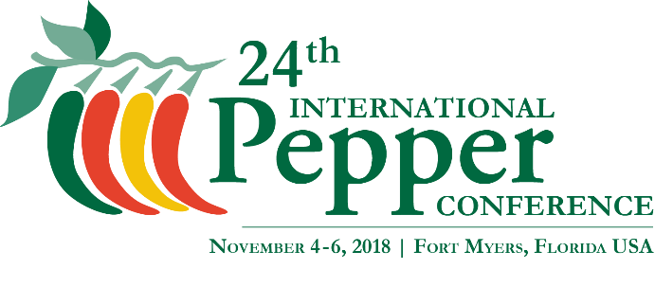
Internal Use Only:
Written Biography
Two Letters of Recommendation
Digital Photograph

Lifetime Achievement Award Nomination Form
Nominator – (Information about you)
Name (First and Last):
Company/Organization:
City/State/Country:
Title:
Email: Phone:

Nominee – (Information about the person you are nominating)
Name (First and Last):
Company/Organization:
City/State/Country:
Title:
Email: Phone:

Indicate the three (3) years this person has attended the International Pepper Conference:
Ex: 17th International Pepper Conference – November 2004 in Naples, FL, USA
- ______________________________________________________________________
- ______________________________________________________________________
- ______________________________________________________________________

Nominations must be submitted by sending one email include all of the following:
- A written, detailed biography on this individual stating:
  - How this individual has contributed outstanding leadership in support of the International Pepper Conference
  - How this individual has made significant contributions to and/or the advancement of Capsicum research, extension, technology and knowledge, and the science of peppers
- At least two (2) letters of recommendation in support of this individual’s nomination
- One digital photograph of the nominated person (JPG File – 300 DPI minimum)

Submit all supporting documents & completed nomination form in one email to:
Beth Miller-Tipton, Director, Conference Coordinator
UF/IFAS Office of Conferences & Institutes
bmt@ufl.edu

Nominations are due Friday, August 31, 2018.

